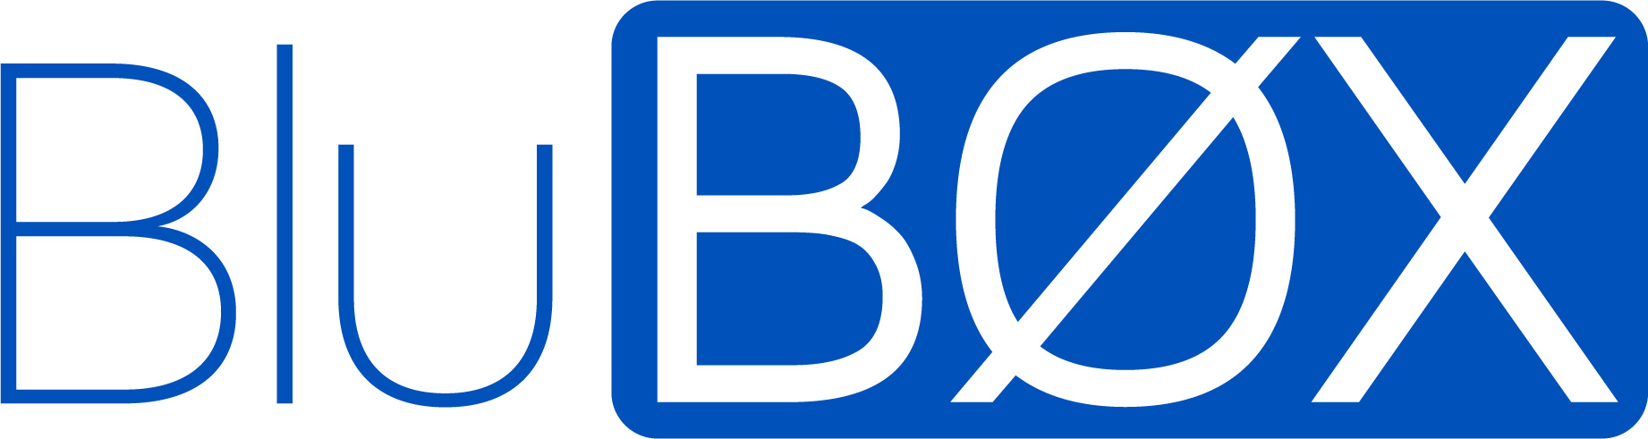

BluID SDK Integration Validation Questions – iOS
February 1, 2022

- iOS SDK Integration Questionnaire
Please provide answers to the questions in the following sections related to the custom application usage of the BluID Mobile Access SDK.
  - General
The following section details general questions related to the custom application integration with the BluID Mobile Access SDK.
Question | Answer
What is the name and version of the BluID Mobile Access custom application? | Application Name:  Application Version:
Provide a brief description of the application
Which version of the BluID SDK are you currently using?
What development language/platform is the application developed in? (For example: Swift, Objective C, Xamarin)
Who will be the end-users of the application? (For example, internal company use, external customer, multiple external customers)
Is this a white-labeled application that will be repackaged and released to multiple end users?
How will the application be deployed to the users post validation?
(Though the App Store or through Mobile Device Management?)
Please provide a link to the app store where the application will be downloadable. If available.

  - Integration
The following section details integration related questions for the custom application integration with the BluID Mobile Access SDK
Question | Answer
Please provide following details used during application development for initializing the SDK: | Application ID:  Application Version:
What opening triggers are supported?

What scanning modes are supported by the application to have the user engage readers?
Does the application support multiple Mobile IDs
How does the application inform people if their device is not on the device compatibility list?
What Metadata does the application display to users?
(For example: Facility Code, Card Number/Mobile ID, Endpoint ID, Last Server Sync Date)
Please provide details on how Mobile IDs be provisioned to users?
For example, will end-users be provisioned Mobile IDs from the BluID Management Portal or through a solution utilizing the BluID Mobile Access API
What other third-party libraries are you using with the application?
When do you plan your initial application release?

  - Implementation
The following section details Implementation use case related questions for the custom application integration with the BluID Mobile Access SDK
Question | Answer
Please provide details on how the device is kept in sync with the BluID Mobile Identities portal.
For example, "Endpoint update is called each time the app is launched and, on a timer, executed once per day" or "we utilize push notifications to perform endpoint update"

Please provide a brief description of the key end-user experiences engaging a reader.
For example, "Our application is primarily focused on temporary visitors to a commercial real estate building that will use the app to engage a Reader with the app in the background and with the device locked".

Please provide the sequence flow diagram or steps for Mobile ID issuance

  - Troubleshooting and Support
The following section details troubleshooting and support related questions for the custom application integration with the BluID Mobile Access SDK
Question | Answer
Describe how users of the application will obtain support for issues relating to Mobile ID management or Usage
Does the application support to provide a diagnostic report?

  - Additional Information
The following section requests for additional information if needed for Partner Services review process for the custom application integration with the BluID Mobile Access SDK
Question | Answer
Can you provide any additional information about the application that can help during the review process?
Include information that may be needed to test your app, such as app-specific settings.
Please provide any sign-in information for a demo account to test Mobile Access.
(Note: The Mobile IDs issued, must use MOB0001 or MOB0022)

Please provide a primary contact email address to be registered for notifications. If you do not have a distribution list set up yet, you can enter your primary technical contact and primary commercial contact below.

If you are adding your primary technical and commercial contact, please follow this format:
1. TECHNICAL CONTACT: Name, Email Address
2. COMMERCIAL CONTACT: Name, Email Address
1.6 Feedback
The following section is for general feedback for usage of the BluID Mobile Access API.
Question | Answer
What other features or enhancements you would like to see in the BluID Mobile Access SDK?
How was your experience integrating with the BluID SDK?
How was your experience with Partner Services during integration?

USA +1 (844)425.8209

Corporate Headquarters
1 Tech Drive, Suite #110
Andover, MA
01810

